A

Project Report on

***Employee Management System***

Submitted in partial fulfilment of the requirement of the degree of

***BACHELOR OF TECHNOLOGY***

Submitted by

Dhruv bhati(18etccs029)

Mohit Menaria(18etccs063)

Jatin Menaria(18ETCCS047)

Suryaveer singh (18ETCCS087)

Computer Science Engineering

TECHNO INDIA NJR INSTITUTE OF TECHNOLOGY ,UDAIPUR

ACKNOWLEDGEMENT

We have taken efforts in this project. However, it would not have been possible without the kind support and help of many Faculties. We would like to extend my sincere thanks to all of them. We highly indebted to **Mr. Aditya Maheshwari** for their guidance and constant supervision as well as for providing necessary information regarding the project & also for their support in completing the project.

We would like to express my gratitude towards my parents & member for their kind co-operation and encouragement which help us in completion of this project. Last but not least. many thanks go to the head of the project, Mr. Aditya Maheshwari whose have invested his full effort in guiding the team in achieving the goal. We have to appreciate the guidance given by other supervisor as well as the panels especially in our project presentation that has improved our presentation skills thanks to their comment and advices.

We would like to express our special gratitude and thanks to all above mentioned people for giving us such attention and time. Our thanks and appreciations also go to our colleague in developing the project and people who have willingly helped us out with their abilities.

Dhruv Bhati

Mohit Menaria

Jatin Menaria

Suryaveer Singh

DECLARATION

We hereby declare that the project work **EMPLOYEE MANAGEMENT SYSTEM** submitted, is a record of an original work done by us under the guidance of **Mr. Aditya Masheshwari** Assistant Professor, Department of Computer Science, **Techno India NJR, Udaipur** and this project work is submitted in the partial fulfilment of the requirements for the award of the Degree of Bachelor of Technology. The results embodied in this report have not been submitted to any other University or Institute for the award of any degree or diploma.

Dhruv Bhati

Mohit Menaria

Jatin Menaria

Suryaveer Singh

TECHNO INDIA NJR INSTITUTE OF TECHNOLOGY ,UDAIPUR

**Department of Computer Science**

**Certificate by Examiners**

Certified that **Dhruv Bhati ,Mohit Menaria ,Jatin Menaria ,Suryaveer Singh** has carried out the project work presented in this report entitled **EMPLOYEE** **MANAGEMENT SYSTEM** for the award of **Bachelor of Technology** from **Techno India NJR**, **Udaipur** under my supervision. The report embodies results of original work, and studies are carried out by the students and the contents of the report do not form the basis for the award of any other degree to the candidate or to anybody else from this or any other University/Institution.

Internal Examiner External Examiner

Date:-………………

ABSTRACT

The “**EMPLOYEE MANAGEMENT SYSTEM**” has been developed to override the problems prevailing in the practicing manual system. This software is supported to eliminate and in some cases reduce the hardships faced by this existing system. Moreover this system is designed for the particular need of the company to carry out operations in a smooth and effective manner. The application is reduced as much as possible to avoid errors while entering the data. It also provides error message while entering invalid data. No formal knowledge is needed for the user to use this system. Thus by this all it proves it is user friendly. Every organization, whether big or small, has human resource challenges to overcome. every organization has different employee management needs, therefore we design exclusive employee management systems that are adapted to your managerial requirements. This is designed to assist in strategic planning, and will help you ensure that your organization is equipped with the right level of human resources for your future goals. Also, for those busy executive who are always on the go, our systems come with remote access features, which will allow you to manage your workforce anytime, at all times. These systems will ultimately allow you to better manage resources. One of the main features in employee management system is time tracking for employees. Effective time tracking mechanism saves both time and money for the organization

**TABLE OF CONTENTS**

**Contents Page**

**no.**

CHAPTER 1 INTRODUCTION 1-3

1.1 Project Detail 1

1.2 Project Scope 2

1.3 Hardware and Software 3

CHAPTER 2 TECHNICAL FEASIBILITY 4-7

2.1Technology Description 4-7

2.1.1HTML 4

2.1.2 Server-Tomcat 5

2.1.3BOOTSTRAP 5

2.1.4MY SQL 6

CHAPTER 3 ER DIAGRAM AND DFD 8-14

3.1 E R Diagram 8-9

3.2 Data Flow Diagram 10-14

CHAPTER 4 BACKEND DESIGN 15-22

4.1 Data Dictionary 15-22

4.2 Database Tables 23-26

CHAPTER 5 FRONTEND DESIGN 23-30

CHAPTER 10 FUTURE SCOPE 31

10.1 Future Scope 31

CHAPTER 11 CONCLUSION 32

**CHAPTER 1**

**INTRODUCTION**

**1.1 Project Detail**

“**EMPLOYEE MANAGEMENT SYSTEM**” The purpose of Employee Management System is to automate the existing manual system by the help of computerized equipment’s and full-fledged computer software, fulfilling their requirements, so that their valuable data/information can be stored for a longer period with easy accessing and manipulation of the same. The required software and hardware are easily available and easy to work with. Employee Management System, as described above, can lead to error free, secure, reliable and fast management system. It can assist the user to concentrate on their other activities rather to concentrate on the record keeping. Thus it will help organization in better utilization of resources. The organization can maintain computerized records without redundant entries. That means that one need not be distracted by information that is not relevant, while being able to reach the information. The aim is to automate its existing manual system by the help of computerized equipments and full-fledged computer software, fulfilling their requirements, so that their valuable data/information can be stored for a longer period with easy accessing and manipulation of the same. Basically the project describes how to manage for good performance and better services for the clients

**1.2 Scope**

Scope of the Project: In a nutshell, it can be summarized that the future scope of the project circles around maintaining information regarding: We can add printer in future. We can give more advance software for Employee Management System including more facilities We will host the platform on online servers to make it accessible world wide Integrate multiple load balancers to distribute the loads of the system Create the master and slave database structure to reduce the overload of the database queries Implement the backup mechanism for taking backup of codebase and database on regular basis on different servers The above mentioned points are the enhancements which can be done to increase the applicability and usage of this project. Here we can maintain the records of employee and salary. Also, as it can be seen that now-a-days the players are versatile, i.e. so there is a scope for introducing a method to maintain the Employee Management System. Enhancements can be done to maintain all the employee, salary, leaves, attendance, registration. We have left all the options open so that if there is any other future requirement in the system by the user for the enhancement of the system then it is possible to implement them. In the last we woundlike thanks all the persons involved in the development of the system directly or indirectly. We hope that the project will serve its purpose for which it is develop there by underlining success of process.

**1.3 Hardware/Software Used**

The hardware requirements Employee Management System are

* Processor: Pentium IV Processor
* Hard Disk: 80 GB HDD
* Ram: 512 MB and above

The software specifications are

* Operating System: Window 7 and above
* HTML, Bootstrap (Front end)
* MY SQL(Back end)
* Tomcat
* Java

**CHAPTER 2**

**2.1.1 Technology Description**

2.1.1 HTML

HTML stands for HYPER TEXT MARKUP LANGUAGE, which is most widely used language on web to develop web pages. HTML refers to the way in which Web pages (HTML documents) are linked together. Thus, the link available on a web page is called Hypertext.

HTML was created by Berners-Lee in late 1991 but “HTML 2.0” was the first standard HTML specification which was published in 1995. HTML 4.01 was a major version of HTML and it was published in late 1999. Though HTML 4.01 version is widely used but currently we are having HTML-5 version which is an extension to HTML 4.01, and this version was published in 2012.

As its name suggests, HTML is a Mark-up Language which means you use HTML to simply “mark-up” a text document with tags that tells a web browser how to structure it to display.

Originally, HTML was develop with the intent of defining the structure of documents like heading, paragraph, lists, and so forth to facilitate the sharing of scientific information between researchers. Now, HTML is being widely used to format web pages with the help of different tags available in HTML.

2.1.2 My SQL

MySQL is an open source RDBMS that relies on SQL for processing the data in database. MySQL provides APIs for the languages like C, C++, Eiffel, JAVA, Perl, PHP and Python. MySQL is most commonly used for web applications and for embedded applications and has become a popular alternative to proprietary database system because of its speed and reliability. MySQL can run on UNIX, Windows and Mac OS.

MySQL is an essential part of almost every open source application. Good examples for /MySQL-based scripts are , os Cmmerce and Joomla. One of the most important things about using MySQL is to have a MySQL specialized host.

MySQL is the most popular Open Source Relational SQL database management system. MySQL is one of the best RDBMS being used for developing web based software applications.

MySQL is an open source relational database management system (RDBMS) based on Structured Query Language (SQL). MySQL runs on virtually all platforms, including Linux, UNIX, and Windows. Although it can be used in a wide range of applications, MySQL is most often associated with web-based applications and online publishing and is an important component of an enterprise stack called LAMP. LAMP is a Web development platform that uses Linux as the operating system, Apache as the Web server, MySQL as the relational database management

2.1.3 Spring Boot

Spring Boot is an open source Java-based framework used to create a micro Service. It is developed by Pivotal Team and is used to build stand-alone and production ready spring applications. This chapter will give you an introduction to Spring Boot and familiarizes you with its basic concepts.

Spring Boot provides a good platform for Java developers to develop a stand-alone and production-grade spring application that you can **just run**. You can get started with minimum configurations without the need for an entire Spring configuration setup.

Advantages

Spring Boot offers the following advantages to its developers −

* Easy to understand and develop spring applications
* Increases productivity
* Reduces the development time

Goals

Spring Boot is designed with the following goals −

* To avoid complex XML configuration in Spring
* To develop a production ready Spring applications in an easier way
* To reduce the development time and run the application independently
* Offer an easier way of getting started with the application

Why Spring Boot?

You can choose Spring Boot because of the features and benefits it offers as given here −

* It provides a flexible way to configure Java Beans, XML configurations, and Database Transactions.
* It provides a powerful batch processing and manages REST endpoints.
* In Spring Boot, everything is auto configured; no manual configurations are needed.
* It offers annotation-based spring application
* Eases dependency management
* It includes Embedded Servlet Container

How does it work?

Spring Boot automatically configures your application based on the dependencies you have added to the project by using **@EnableAutoConfiguration** annotation. For example, if MySQL database is on your classpath, but you have not configured any database connection, then Spring Boot auto-configures an in-memory database.

The entry point of the spring boot application is the class contains **@SpringBootApplication** annotation and the main method.

Spring Boot automatically scans all the components included in the project by using **@ComponentScan** annotation.

**CHAPTER: 3**

**ER DIAGRAM AND DFD**

**3.1 ER Diagram**

The Entity-Relationship Data Model (ERD) perceives the real world as consisting of basic objects, called entity & relationship among these objects.

It was developed to facilitate database design by allowing specification of an enterprise schema, which represents overall logical structure of a database. The ERD model is very useful in mapping the meaning & interactions of the outside world enterprises onto a conceptual schema.

**The ERD model consists of the following major components**

* ELLIPSE which represents attributes.
* RECTANGLES which represents entity-sets.
* DIAMONDS which represents the relationship sets.
* LINES which link attributes to entity sets to relationship sets.

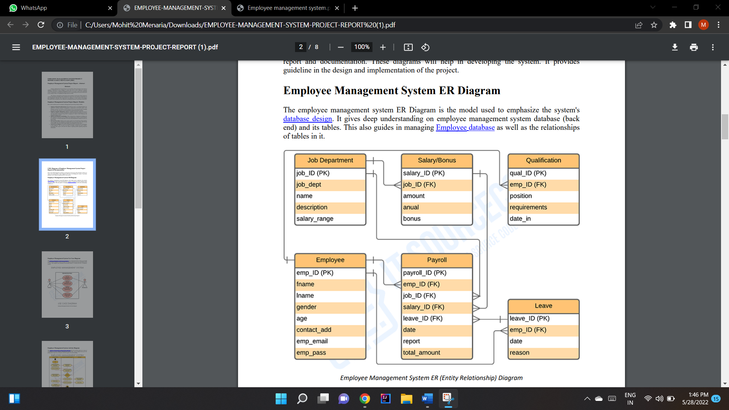

**3.2 DFD**

A data flow diagram is graphical tool used to describe and analyze movement of data through a system. These are the central tool and the basis from which the other components are developed. The transformation of data from input to output, through processed, may be described logically and independently of physical components associated with the system.

These are known as the logical data flow diagrams. The physical data flow diagrams show the actual implements and movement of data between people, departments and workstations.

A full description of a system actually consists of a set of data flow diagrams. Using two familiar notations Yourdon, Gane and Sarson notation develops the data flow diagrams. Each component in a DFD is labeled with a descriptive name. Process is further identified with a number that will be used for identification purpose.

The development of DFD’S is done in several levels. Each process in lower level diagrams can be broken down into a more detailed DFD in the next level. The lop-level diagram is often called context diagram.

It consists single process bit, which plays vital role in studying the current system. The process in the context level diagram is exploded into other process at the first level DFD.

The idea behind the explosion of a process into more process is that understanding at one level of detail is exploded into greater detail at the next level. This is done until further explosion is necessary and an adequate amount of detail is described for analyst to understand the process.

**DFD SYMBOLS:**

In the DFD, there are four symbols:

* A square defines a source(originator) or destination of system data
* An arrow identifies data flow. It is the pipeline through which the information flows
* A circle or a bubble represents a process that transforms incoming data flow into outgoing data flows.
* An open rectangle is a data store, data at rest or a temporary repository of data

**DFD (Data Flow Diagrams)**

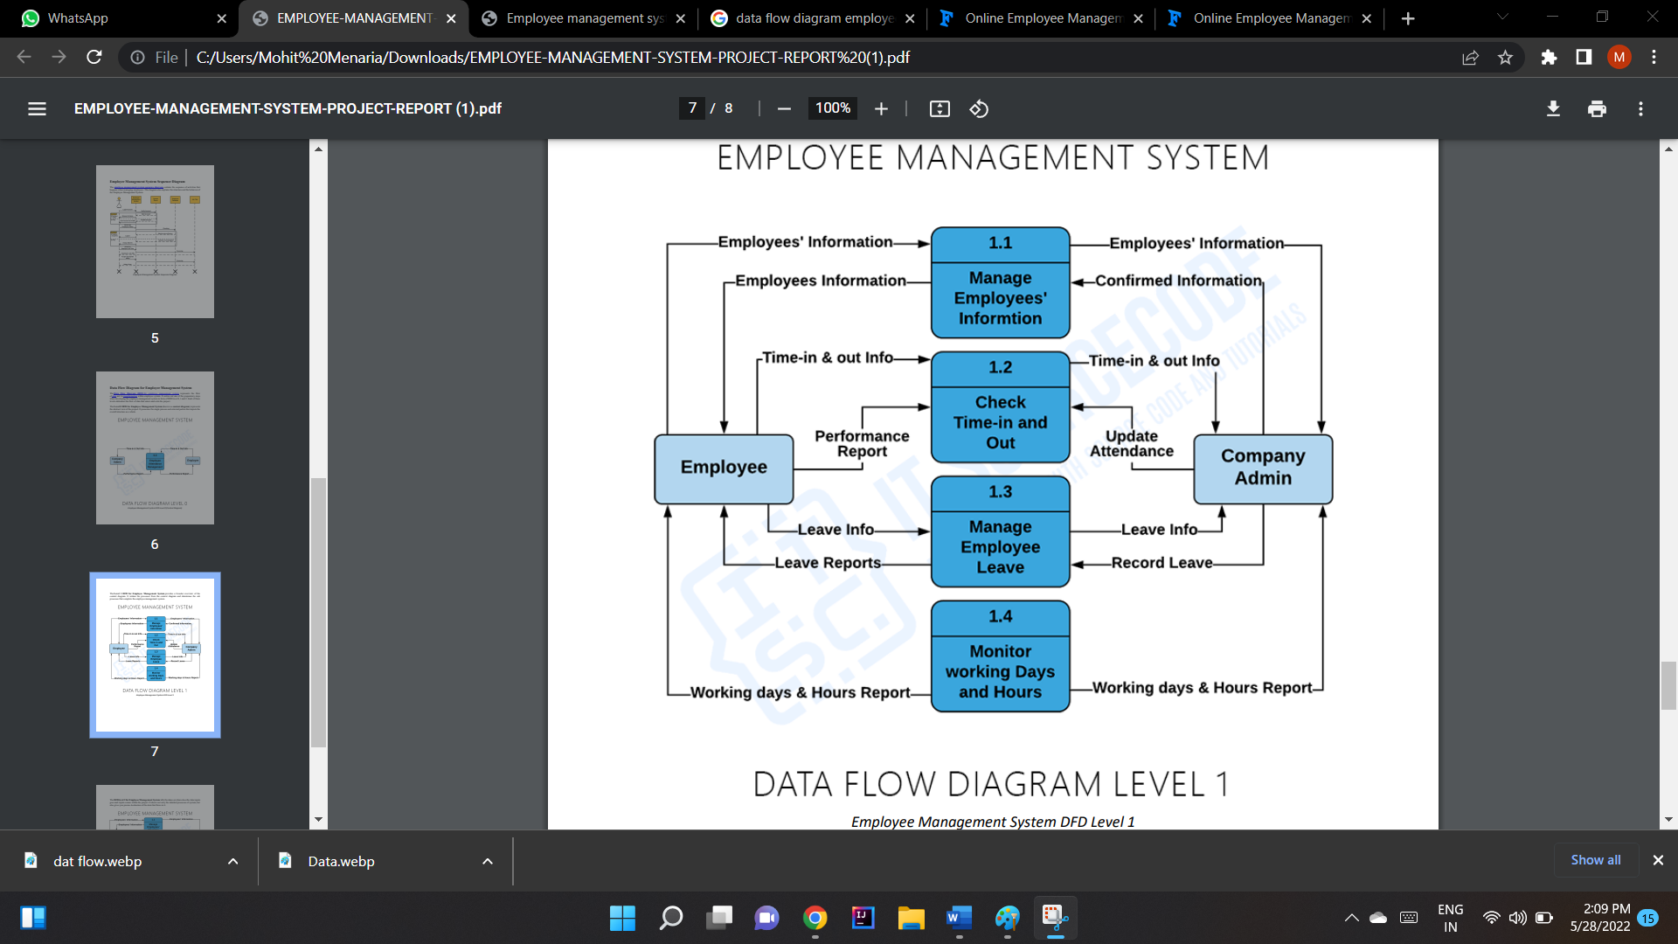

**CHAPTER: 4**

**BACKEND DESIGN**

**4.1 Data Dictionary**

A data dictionary, or Metadata Repository, as defined in the IBM Dictionary of Computing, is a "centralized repository of information about data such as meaning, relationships to other data, origin, usage, and format. The term can have one of several closely related meanings pertaining to databases and database management systems (DBMS):

* A document describing a database or collection of databases.
* An integral component of a DBMS that is required to determine its structure.
* A piece of middleware that extends or supplants the native data dictionary

of a DBMS.

The terms data dictionary and data repository indicate a more general software utility than a catalogue. A catalogue is closely coupled with the DBMS software. It provides the information stored in it to the user and the DBA, but it is mainly accessed by the various software modules of the DBMS itself, such as DDL and DML compilers, the query optimizer, the transaction processor, report generators, and the constraint enforcer. On the other hand, a data dictionary is a data structure that stores metadata, i.e., (structured) data about information. The software package for a stand-alone data dictionary or data repository may interact with the software modules of the DBMS, but it is mainly used by the designers, users and administrators of a computer system for information resource management. These systems maintain information on system hardware and software configuration, documentation, application and users as well as other information relevant to system administration.

If a data dictionary system is used only by the designers, users, and administrators and not by the DBMS Software, it is called a passive data dictionary. Otherwise, it is called inactive data dictionary or data dictionary. When a passive data dictionary is updated, it is done so manually and independently from any changes to a DBMS (database) structure. With an active data dictionary, the dictionary is updated first and changes occur in the DBMS automatically as a result.

**4.2 Database Tables**

In the “Employee Management System “ some of them are as follows:

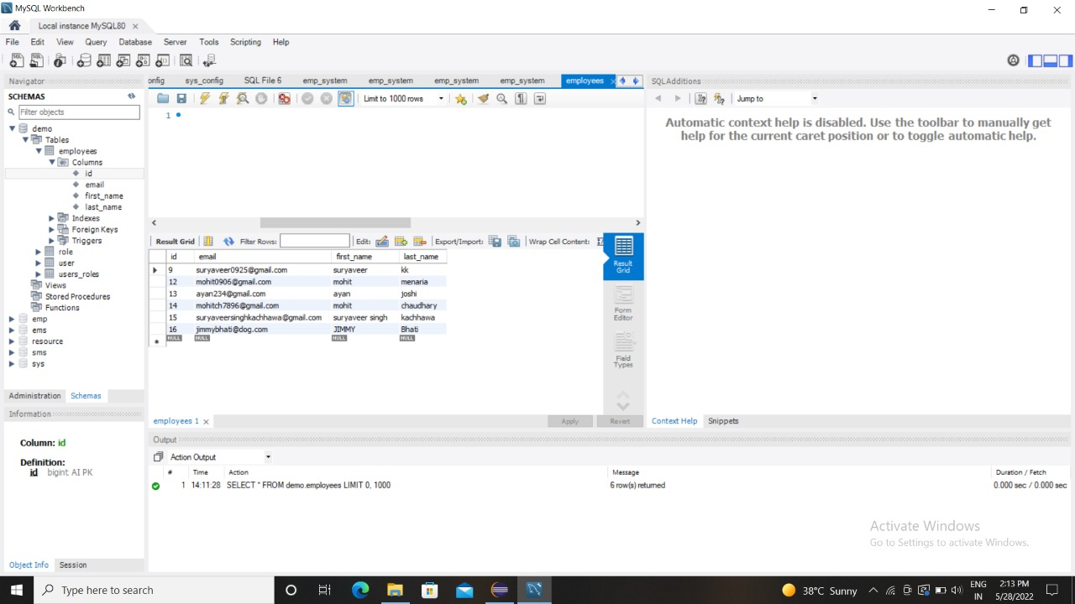

**CHAPTER 5**

**FRONTEND DESIGN**

**Login**

Login is the process by which an individual gains access to a system by identifying and authenticating themselves. Basically using following form employee and admin gain access to the system. The person have to fill the user name and unique password and the press to the submit button.

5.1.2.1 Employee Login

Employee login access the full system and can add or delete employees as well. The admin have to fill the user name and unique password and the press to the submit button to access admin area. Admin view all products details and users details.

Fig 5.2 Admin Login

**5.1.2.2** Employee **Login**

Employee Login is the process by which an employee gains access to a

computer system by identifying and authenticating themselves. The user have to fill the user name and user Email and the press to the Register button.

**Fig 5.3 Employee Login**

**CHAPTER 6**

**FUTURE SCOPE :**

Future Scope of the Project: In a nutshell, it can be summarized that the future scope of the project circles around maintaining information regarding: We can add printer in future. We can give more advance software for Employee Management System including more facilities We will host the platform on online servers to make it accessible world wide Integrate multiple load balancers to distribute the loads of the system Create the master and slave database structure to reduce the overload of the database queries Implement the backup mechanism for taking backup of codebase and database on regular basis on different servers The above mentioned points are the enhancements which can be done to increase the applicability and usage of this project. Here we can maintain the records of employee and salary. Also, as it can be seen that now-a-days the players are versatile, i.e. so there is a scope for introducing a method to maintain the Employee Management System. Enhancements can be done to maintain all the employee, salary, leaves, attendance, registration. We have left all the options open so that if there is any other future requirement in the system by the user for the enhancement of the system then it is possible to implement them. In the last we wouldlike to thanks all the persons involved in the development of the system directly or indirectly. We hope that the project will serve its purpose for which it is develop there by underlining success of process

**CHAPTER 7**

**CONCLUSION**

Our project is only a humble venture to satisfy the needs to manage their project work. Several user friendly coding have also adopted. This package shall prove to be a powerful package in satisfying all the requirements of the school. The objective of software planning is to provide a frame work that enables the manger to make reasonable estimates made within a limited time frame at the beginning of the software project and should be updated regularly as the project progresses. λ A description of the background and context of the project and its relation to work already done in the area. λ Made statement of the aims and objectives of the project. λ The description of Purpose, Scope, and applicability. λ We define the problem on which we are working in the project. λ We describe the requirement Specifications of the system and the actions that can be done on these things. λ We understand the problem domain and produce a model of the system, which describes operations that can be performed on the system. λ We included features and operations in detail, including screen layouts.